**Harman Java Assignment day 1**

**Q1. Loose coupling and high cohension.**

**package** day1;

**public** **class** Q1 {

**public** **static** **void** main(String[] args) {

**int** a[]=**new** **int**[20];

a[0]=1;

a[1]=1;

**float** avg=2;

System.***out***.print("fab nos are"+a[0]+","+a[1]);

**for**(**int** i=2;i<20;i++)

{

a[i]=a[i-2]+a[i-1];

System.***out***.print(","+a[i]);

avg=avg+a[i];

}

**Q2**. **Encapsulation and abstraction**

**package** day1;

**import** java.util.*;

**public** **class** Q2 {

**public** **static** **void** main(String[]args)

{

Scanner s=**new** Scanner(System.***in***);

System.***out***.println("enetr no. of students");

**int** numStudents=s.nextInt();

**float** a[]= **new** **float**[numStudents];

**float** k=0;

s.close();

**float** GradesAverage;

System.***out***.println("enter grades of students");

**for**(**int** i=0;i<numStudents;i++)

{

a[i]=s.nextFloat();

**while**(a[i]<0 || a[i]>100)

{

System.***out***.println("Grow up kiddo, try again");

a[i]=s.nextFloat();

}

}

**for**(**int** i=0;i<numStudents;i++)

{

{

k=k+a[i];

}

}

GradesAverage=k/numStudents;

System.***out***.println("Average score of class is"+GradesAverage);

}

}

**Q3.**

**package** day1;

**import** java.util.*;

**public** **class** Q3 {

**public** **static** **void** main(String[] args)

{

Scanner s= **new** Scanner(System.***in***);

System.***out***.println("enter no of elements");

**int** n=s.nextInt();

**int** a[]= **new** **int**[n];

System.***out***.println("enter elements in array");

**for**(**int** i=0;i<n;i++)

{

a[i]= s.nextInt();

}

**int** c[]=*copyOf*(a);

**for**(**int** i=0;i<n;i++)

{

System.***out***.println("copied array is"+c[i]);

}

s.close();

}

**public** **static** **int**[] copyOf(**int**[]array)

{

**int**[]b= **new** **int**[array.length];

**for**(**int** i=0;i<array.length;i++)

{

b[i]=array[i];

}

**return** b;

}

}

**Q4. Code to print pascal triangle.**

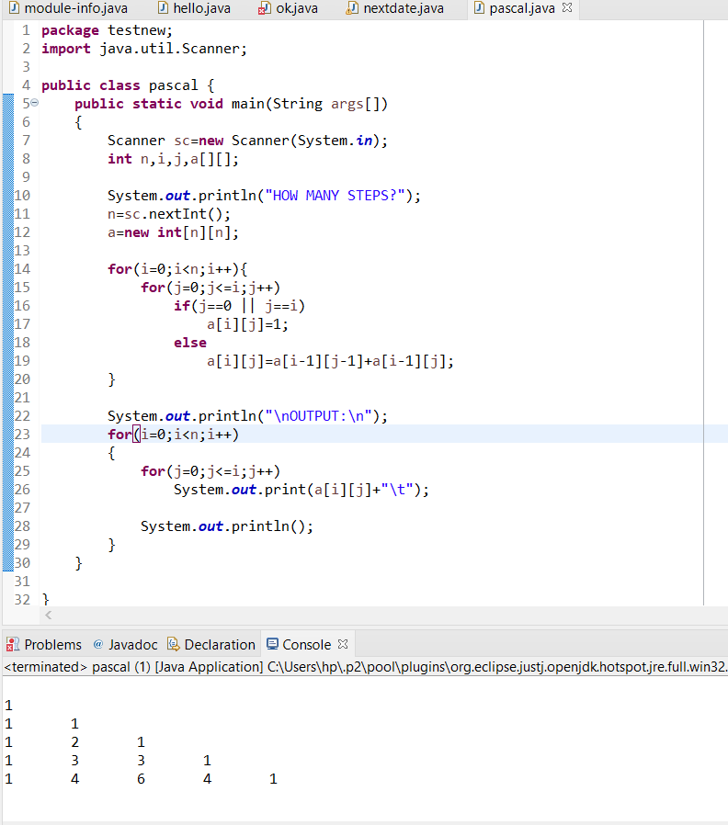

**Q5.**

**package** day1;

**import** java.util.*;

**public** **class** Q5 {

**public** **static** **void** main(String[]args)

{

**int** day, month, year;

Scanner scanner = **new** Scanner(System.***in***);

System.***out***.println("PE day");

day = scanner.nextInt();

System.***out***.println("PE month");

month = scanner.nextInt();

System.***out***.println("PE year");

year = scanner.nextInt();

System.***out***.println("current date: " + day + "/" + month + "/" + year);

scanner.close();

**int** noOfDaysInMonth[]={-1, 31,28,31,30,31,30,31,31,30,31,30,31};

**if**(*isLeapYear*(year)){

noOfDaysInMonth[2]=29;

}

day=day+1;

**if**(day > noOfDaysInMonth[month]){

day=1;

month++;

**if**(month > 12){

month=1;

year++;

}

}

System.***out***.println("next date: " + day + "/" + month + "/" + year);

}

**public** **static** **boolean** isLeapYear(**int** year) {

**if** ((year % 400 == 0 || year % 100 != 0) && (year % 4 == 0))

**return** **true**;

**else**

**return** **false**;

}

}